Business Question:
- What is the distribution of the difference in the resale value of the car (selling price vs MMR price)?
- What features are important to contribute to deciding the selling price of a used car?

We explored and analyzed a large dataset of used vehicle sales to determine how different car features can affect the selling price based on various car characteristics such as year, make, model, trim, condition, odometer reading, body type, transmission, and state of sale. An important aspect of this study is to understand how the MMR (Manheim Market Report) value, a widely used industry benchmark for pricing vehicles, differs from the actual selling price. We aim to uncover whether vehicles are sold above or below their estimated market value, and identify which factors contribute to this variation by comparing the difference between the MMR and the actual selling price.

Understanding the pricing deviations can provide valuable insights for dealerships, buyers, and pricing analysts to help identify patterns, estimate fair market value, and make more data-driven decisions in vehicle pricing and negotiation.

To begin the analysis, we created another column called sales difference and performed summary statistics on the dataset using describe(). This helped us understand the distribution of numerical variables such as sellingprice, mmr, odometer and sales difference. This provided key insights such as:
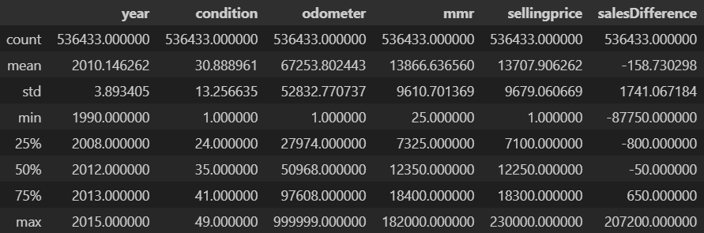
The selling price is $158 less than the MMR. 25% of the cars either sell 800$ below the mmr or 650$ above the mmr. A car was sold for 87,750$ less than the MMR which suggests its an outlier.

A car was sold for $207,200 more than the MMR which also suggests its an outlier. The standard deviation is 1741.0671 which is relatively large compared to the mean. This shows us there are many outliers.

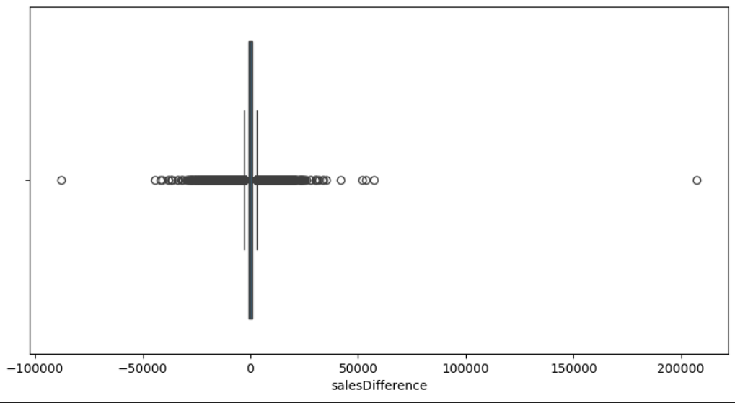
Lastly, we created a plot that has long whiskers and many points outside the range, suggesting the presence of significant outliers.

year condition odometer mmr sellingprice salesDifference
count 503110.000000 503110.000000 503110.000000 503110.000000 503110.000000 503110.000000
mean 2010.088126 31.214583 68227.995442 13426.114070 13376.420320 -49.915855
std 3.931794 12.997754 52906.964345 9059.822551 9124.905015 1068.442540
min 1990.000000 1.000000 1.000000 25.000000 1.000000 -2700.000000
25% 2008.000000 25.000000 28652.000000 7000.000000 7000.000000 -700.000000
50% 2012.000000 35.000000 51958.500000 12150.000000 12100.000000 -25.000000
75% 2013.000000 42.000000 98990.000000 17950.000000 18000.000000 600.000000
max 2015.000000 49.000000 999999.000000 182000.000000 183000.000000 2500.000000
Even after applying IQR-based filtering and Winsorization, the standard deviation of several variables remains larger than the mean. This is expected because the dataset contains a wide variety of vehicles with naturally different price ranges and mileage levels. The goal of the cleaning process was not to artificially compress the distribution, but to remove extreme outliers that would distort the regression model.

Model A
Due to the variation in vehicle selling prices and several extreme outliers, we decided to build a base model (Model A) to check how well the raw data performs before data cleaning.

The selling price was used as the dependent variable, and multiple categorical and numerical features were used as predictors:

Call:
lm(formula = sellingprice ~ year + make + model + trim + body +
transmission + state + condition + odometer + color + interior,
data = sample_df)

Coefficients: (121 not defined because of singularities)
Estimate Std. Error t value Pr(>|t|)
(Intercept) 1.920e+04 4.503e+03 4.264 2.02e-05 ***
year1991 7.979e+02 3.710e+03 0.215 0.829747
.
makeBentley 4.516e+04 3.754e+03 12.030 < 2e-16 ***

Residual standard error: 2984 on 18437 degrees of freedom
Multiple R-squared: 0.9124, Adjusted R-squared: 0.905
F-statistic: 123 on 1562 and 18437 DF, p-value: < 2.2e-16

The summary of modelA suggests that the model is statistically significant, because the model has a pvalue of < 0.01 which shows the model variables are significant to estimate the selling price. The multiple R-squared value suggests that modelA explains the variance (.9124) in the selling price and the adjusted R-squared value (.905) explains that the model still holds after accounting for predictors.
However, Coefficients: (121 not defined because of singularities)suggests that 121 variables were removed by R automatically because they caused perfect multicollinearity.
While running the test to see the dependent variables using alias function, it reveals that certain variables are perfectly dependent on others. For example,
- Model15001 was removed because it can be predicted from the other model columns
- trim* variables has too many categories and only a few appear a few times.
- When combining year, make and trim, they create thousands of dummy variables out of which many are redundant.

Running ANOVA, we can compare each categorical variable against the response variable (sellingprice) to find the statistical signficance of each variable:

> anova(modelA)
Analysis of Variance Table

Response: sellingprice
Df Sum Sq Mean Sq F value Pr(>F)
year 25 6.9526e+11 2.7810e+10 3122.2988 < 2.2e-16 ***
make 46 4.0071e+11 8.7111e+09 978.0010 < 2.2e-16 ***
model 554 4.3697e+11 7.8876e+08 88.5554 < 2.2e-16 ***
trim 807 1.2539e+11 1.5538e+08 17.4452 < 2.2e-16 ***
body 17 4.8228e+09 2.8370e+08 31.8508 < 2.2e-16 ***
transmission 2 1.6659e+08 8.3295e+07 9.3516 8.724e-05 ***
state 37 3.6482e+09 9.8599e+07 11.0699 < 2.2e-16 ***
condition 40 2.5779e+10 6.4448e+08 72.3572 < 2.2e-16 ***
odometer 1 1.7314e+10 1.7314e+10 1943.8195 < 2.2e-16 ***
color 17 2.2520e+08 1.3247e+07 1.4873 0.088690 .
interior 16 3.3433e+08 2.0896e+07 2.3460 0.001776 **
Residuals 18437 1.6422e+11 8.9070e+06

Compared to other categorical variables, color is the least significant and interiors is the next. We dropped the column because it will not have a significant impact on the selling price. However, we can see that the model and trim have many categories that can cause singularities and VIF errors.
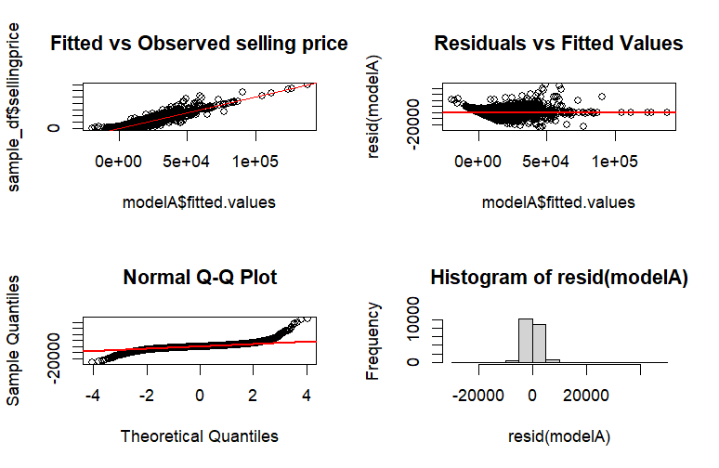
By plotting a scatter plot with fitted values of modelA with selling price, we can observe that most of the values are along the abline. This means as the price actually increases, the predicted price also increases. The model is able to capture the trend correctly. The residuals vs Fitted values implies the values are following a pattern and not randomly scattered. The Q-Q plot is normally distributed and is not skewed. However, the histogram of the residuals is binomial which states that the data is problematic and has alot of tails.

All the above data suggests that there are outliers and a few variables have multicollinearity.

Model B
To improve the quality of the dataset and ensure a more robust regression model, we implemented a two-step outlier removal process using Interquartile Range (IQR) followed by Winsorization. The first step focused on removing extreme outliers, while the second step handled more moderate values to prevent them from influencing the model excessively.Step 1 - Outlier Detection
I calculated the 25th percentile (Q1) and 75th percentile (Q3) of the salesDifference variable and computed the Interquartile Range (IQR = Q3 − Q1). Any data point outside this range was considered an outlier and removed. This step helped eliminate extreme variability and reduce noise, resulting in a cleaner and more reliable dataset for modeling.Step 2 - Winsorization (Capping Extreme Values)
After filtering using IQR, we further reduced the influence of high but valid values using Winsorization. We capped salesDifference at the 1st and 99th percentiles of the cleaned data using the clip() function. This method preserves all observations but limits the impact of extreme values, making the distribution more stable and suitable for linear regression.
The remaining variation represents legitimate market differences and should remain in the dataset to ensure the model captures real-world pricing behavior.
Call:
lm(formula = sellingprice ~ factor(year) + make + model + trim +
body + transmission + state + condition + odometer + color +
interior, data = sample_df2)
Coefficients: (126 not defined because of singularities)
Estimate Std. Error t value Pr(>|t|)
(Intercept) 2.467e+04 3.710e+03 6.649 3.04e-11 ***
factor(year)1991 -3.452e+03 4.206e+03 -0.821 0.411798
makeBentley 4.802e+04 2.228e+03 21.554 < 2e-16 ***
Residual standard error: 2666 on 18465 degrees of freedom
Multiple R-squared: 0.9238, Adjusted R-squared: 0.9175
F-statistic: 145.9 on 1534 and 18465 DF, p-value: < 2.2e-16

The summary of modelB suggests that modelB is better than modelA and is statistically significant as the model has pvalue of < 0.01 and also signifies that all the model variables are significant to estimate the selling price. The multiple R-squared value suggests that modelA explains .9238 of the variance in the selling price and the adjusted R-squared value .9175 explains that the model still holds after accounting for predictors.
However, Coefficients: (126 not defined because of singularities)suggests that 126 variables were removed by R automatically because they caused perfect multicollinearity.
Anova
> anova(modelB)
Analysis of Variance Table
Kurumi, check out model graphs 730 file i am making changes there. Ive added model 3 info there with the screenshots of anova.
Response: sellingprice
Df Sum Sq Mean Sq F value Pr(>F)
factor(year) 25 6.7481e+11 2.6992e+10 3798.3277 < 2.2e-16 ***
make 47 3.5282e+11 7.5068e+09 1056.3446 < 2.2e-16 ***
model 531 4.0423e+11 7.6126e+08 107.1236 < 2.2e-16 ***
trim 801 1.1443e+11 1.4285e+08 20.1023 < 2.2e-16 ***
body 17 4.8983e+09 2.8814e+08 40.5461 < 2.2e-16 ***
transmission 2 3.4146e+08 1.7073e+08 24.0247 3.800e-11 ***
state 37 2.1134e+09 5.7119e+07 8.0378 < 2.2e-16 ***
condition 39 1.4949e+10 3.8329e+08 53.9367 < 2.2e-16 ***
odometer 1 2.1481e+10 2.1481e+10 3022.8043 < 2.2e-16 ***
color 19 2.0524e+08 1.0802e+07 1.5201 0.06802 .
interior 15 7.1327e+08 4.7551e+07 6.6913 1.231e-14 ***
Residuals 18465 1.3122e+11 7.1064e+06
---
Signif. codes: 0 ‘***’ 0.001 ‘**’ 0.01 ‘*’ 0.05 ‘.’ 0.1 ‘ ’ 1

With the anova test, we can compare all categorical variables with the dependent variable (selling price). We can see that model and trim has way too many categories which can cause singularities and VIF errors. Color is the least significant and dropping the column does not impact the selling price much.

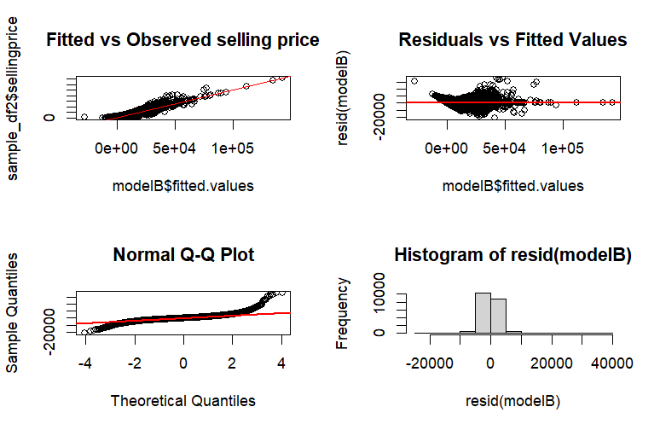
We created four plots to help determine whether our model is valid. Using a scatter plot we compared the model’s fitted values with selling price and observed that most of the values are along the abline. When the price increases, the predicted price also increases, therefore the model is able to properly capture the trend we expect to see. The Residuals vs Fitted values shows the values are following a pattern and not randomly scattered. The Q-Q plot is normally distributed and is not skewed. However, the histogram of the residuals is binomial which shows that the data is problematic and has a lot of tails.

From the two models, modelB is better than modelA, but they both run into the problem of multicollinearity due to the dummy variables from trim and model.

